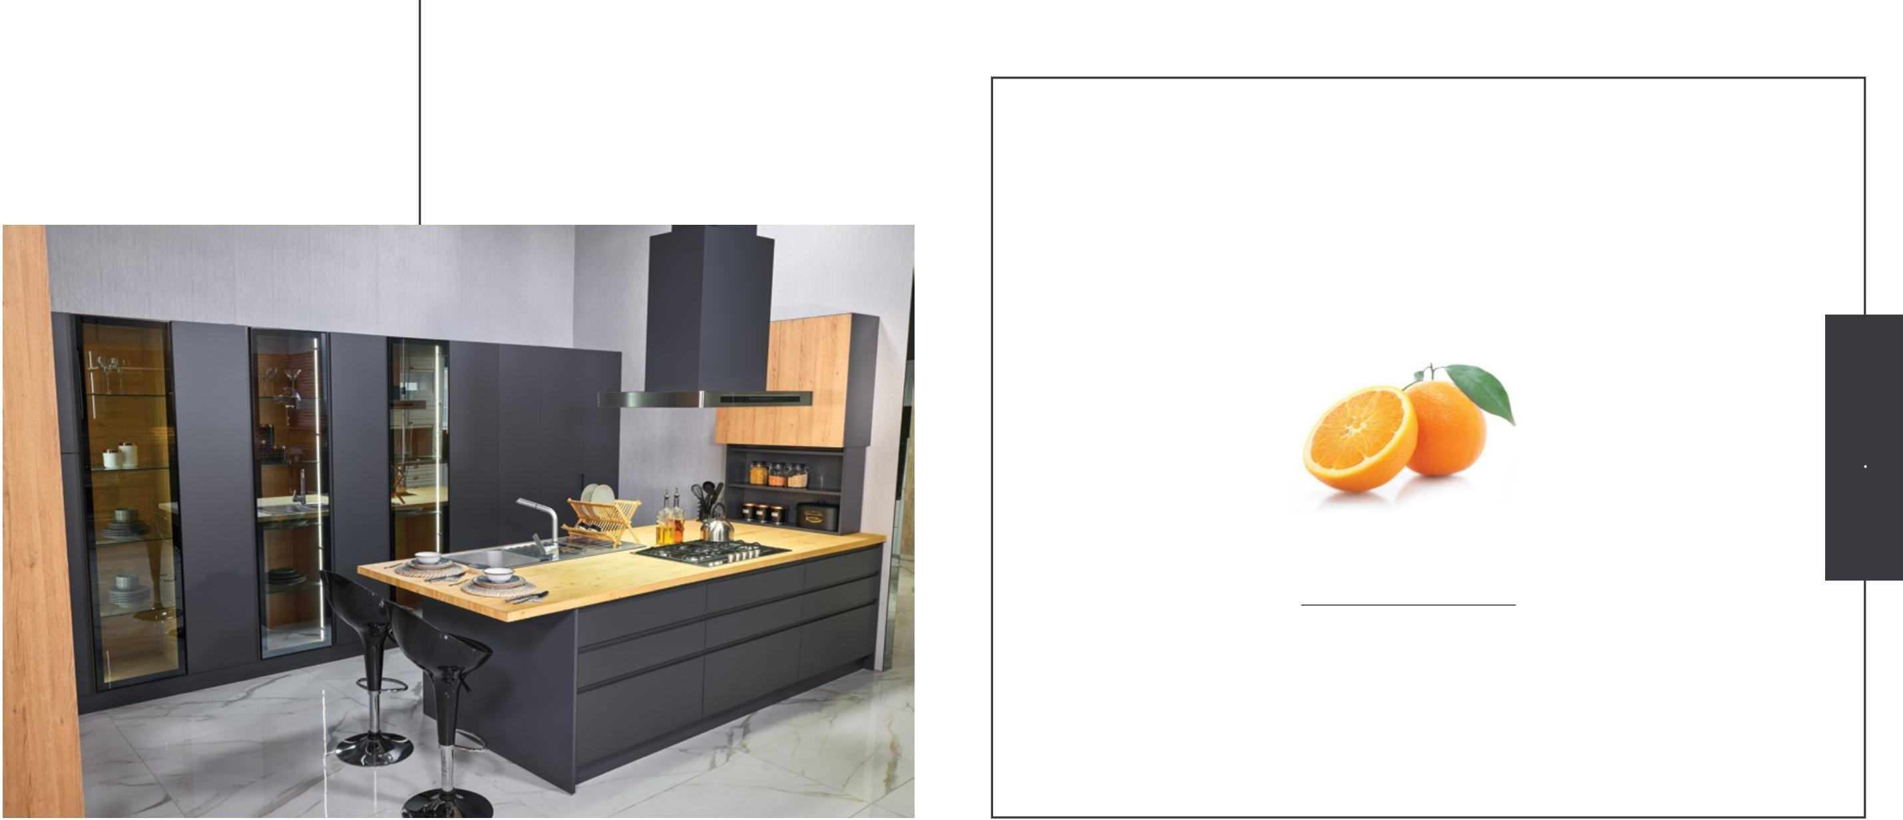

## BOLD

Bold, which brings a new breath to the kitchen understanding with its glass details, is the favorite of those who cannot give up stylish touches!

We have designed and produced our kitchen model, which combines elegant points with comfort, in a form that can meet your needs.

With its glass details that bring a fresh breath to kitchen design, Bold is the favorite by those who can't give up elegance! We designed and produced our kitchen, which combines comfort and graceful details, in a way that can meet your needs.

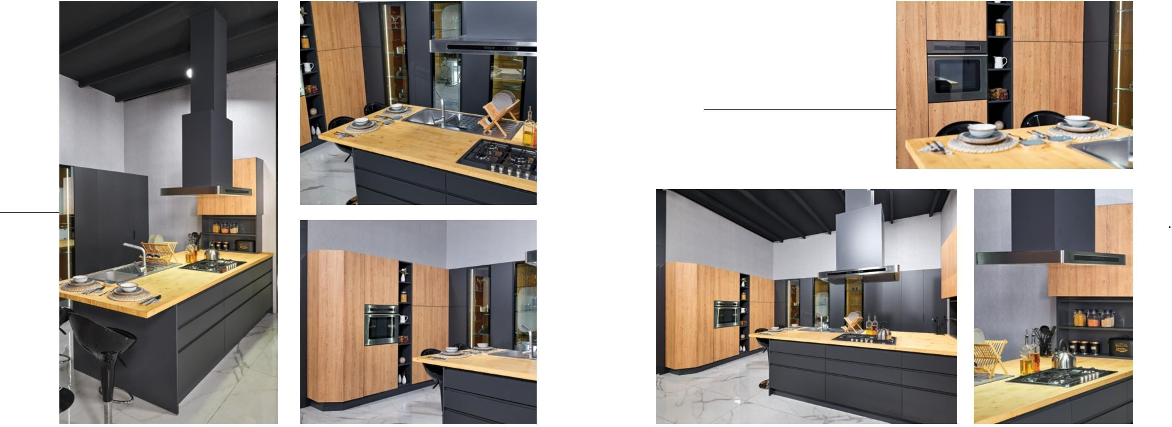With cabinets designed in vertical form and glass details, everything is at your fingertips!

Glass details and vertical cabinets provide ease of use while providing comfort. you will feel.

With cabinets and glass details designed in vertical form, everything is at hand!

While the glass details and vertical cabinets provide ease of use, you will feel the comfort.

*LAC-STR-1091*

Cover | Door : *Lac-Structur*

Model : *Z10-C0A*

Color | Color : *ST01*

Body | Cabinet : *0309-MKLL*

Handle | Handle: *Stepforming*

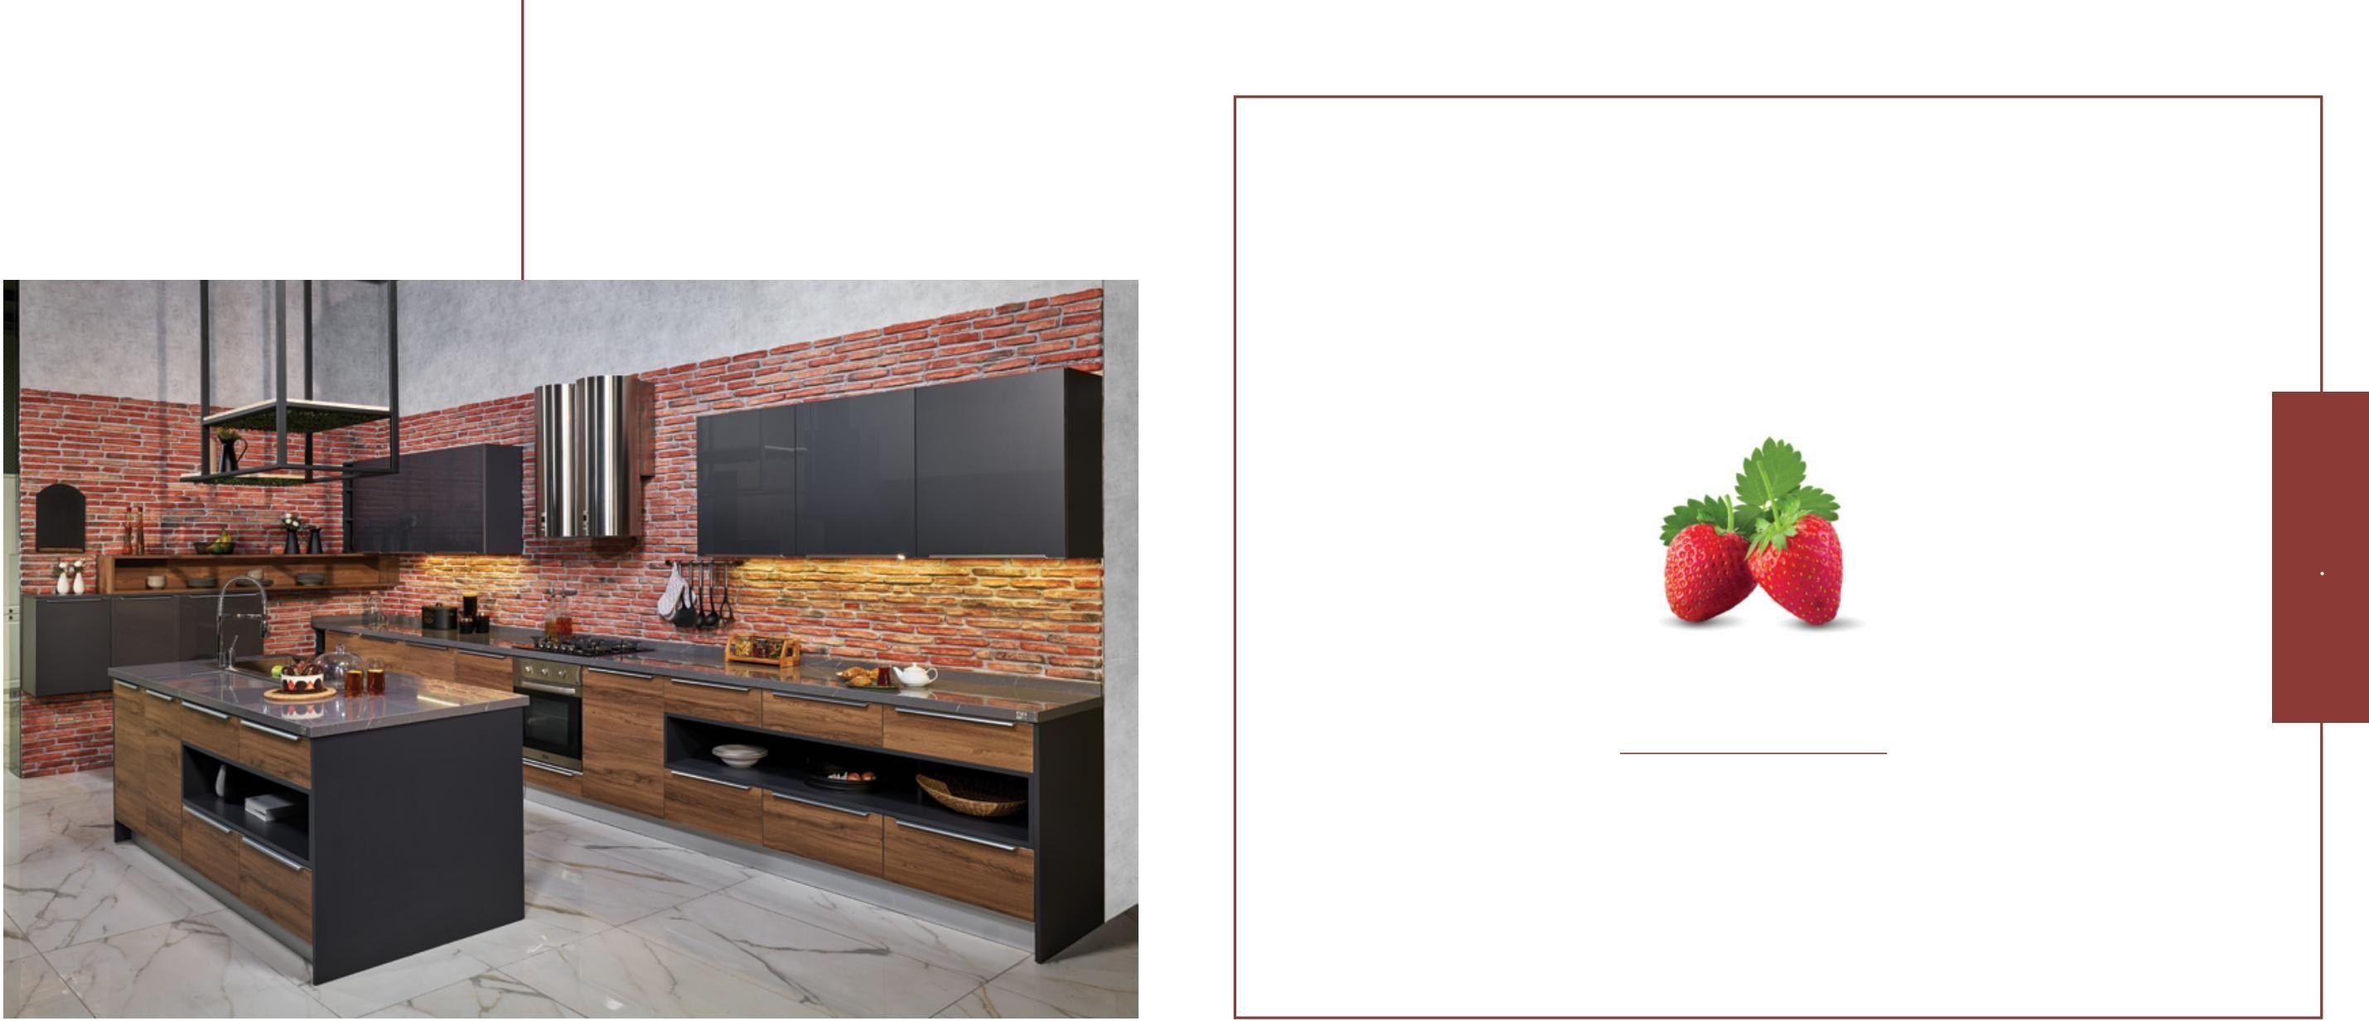

##### LIGNUM

##### MODERN STYLE

Meet Yourself in Sharp Lines!

## LIGNUM

We brought together the extraordinary details that will add elegance to your kitchen

with the loft concept! For those who like to act freely, Lignum, which has many uses; It draws attention with its decorative showcase, island counter and sharp lines.

We have brought together the extraordinary details that will add color to your kitchen with the loft concept!

Lignum has plenty of space for those who love to act freely; It draws attention with its decorative shelf, kitchen island and

sharp lines.

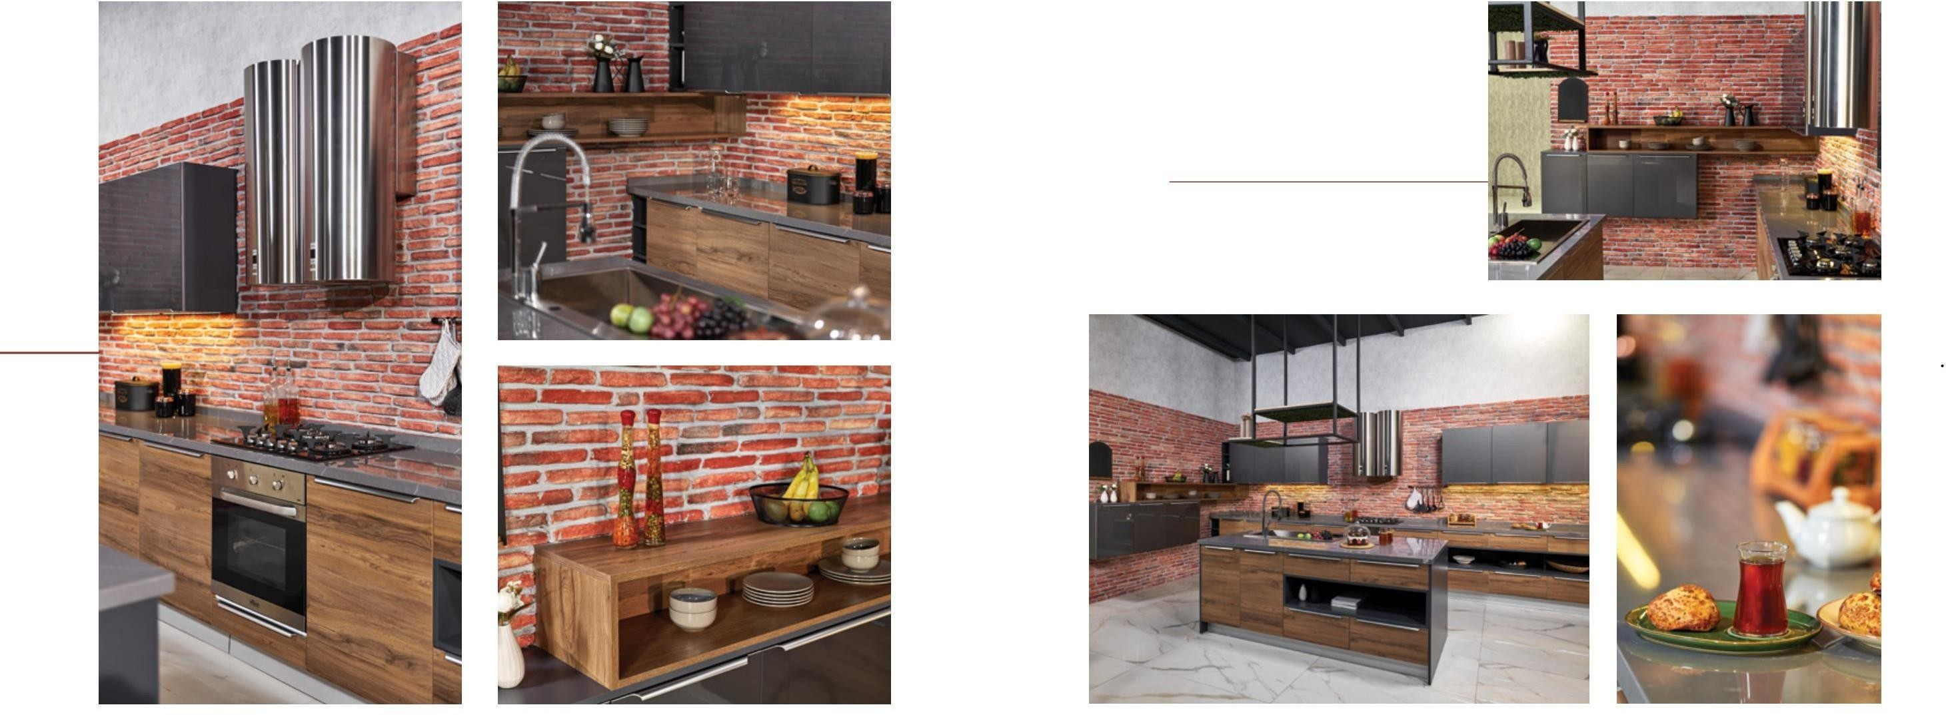Lignum, which has many shelves, is indispensable for large families!

While providing great convenience in the kitchen with its island counter and large sink, you can feel comfort and elegance together with ergonomic cabinets as well as showcases that you can decorate as you wish.

Lignum, which has a lot of shelves, is a must for large families!

While providing great convenience in the kitchen with kitchen island and large sink, you can feel comfort and elegance together with ergonomic cabinets and shelves that you can decorate as you wish.

###### ACRSTR-1090

Cover | Door : *Acrylic-Structur*

Model : *Z001-S0G2*

Color | Color : *B12-C0C* Body | Cabinet : *0309-MKLL* Handle | Handle: *Integrated*

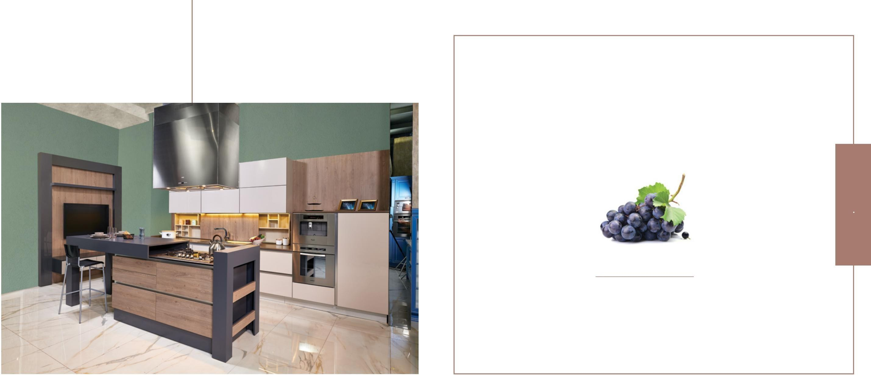

##### SLIDER

##### MODERN STYLE

Both Modern and Comfortable!

## SLIDER

Slider, which can be shaped according to

your needs, stands out with its functions where you can feel comfort in every corner!

Slider, which can be configured according to your needs, stands out with its functions that you can feel the comfort in every corner!

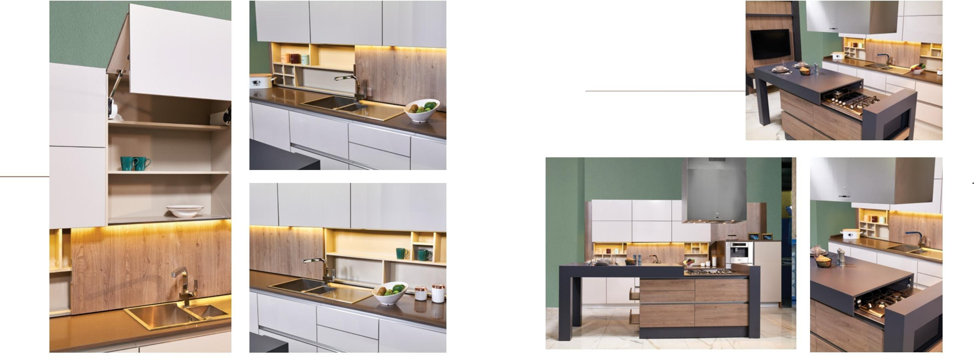With its remote control cabinets and many conveniences, cooking is now much easier!

The Slider, which can be an island counter or a table whenever you wish, gives you the chance to be more free in your kitchen as it has a sliding cabinet behind the sink as well as its counter.

With its remote controlled cabinets and many conveniences, cooking is now much easier!

Slider, which can be used as bench or table whenever you want, gives you chance to act freely in your kitchen, with its sliding cabinet behind the sink.

*ACRSTR-1092*

Cover | Door : *Acrylic-Structur*

Model : *Z001-S001*

Color | Color : *B23-C33* Body | Cabinet : *0330-MKYL* Handle | Handle :

### MIMOSA

### MODERN STYLE

Reflect Your Kitchen With Unusual Colors!

**MIMOSA**

A unique design for those who want to find everything they are looking for in their kitchen!

Mimoza is waiting to take its place in your kitchen with its stylish design and fresh colors besides its modern lines.

Mimosa is a unique design intended for individuals that would like a comprehensive kitchen area.

Mimoza is waiting to take its place in your kitchen with its stylish design and fresh colors as well as

its modern lines.

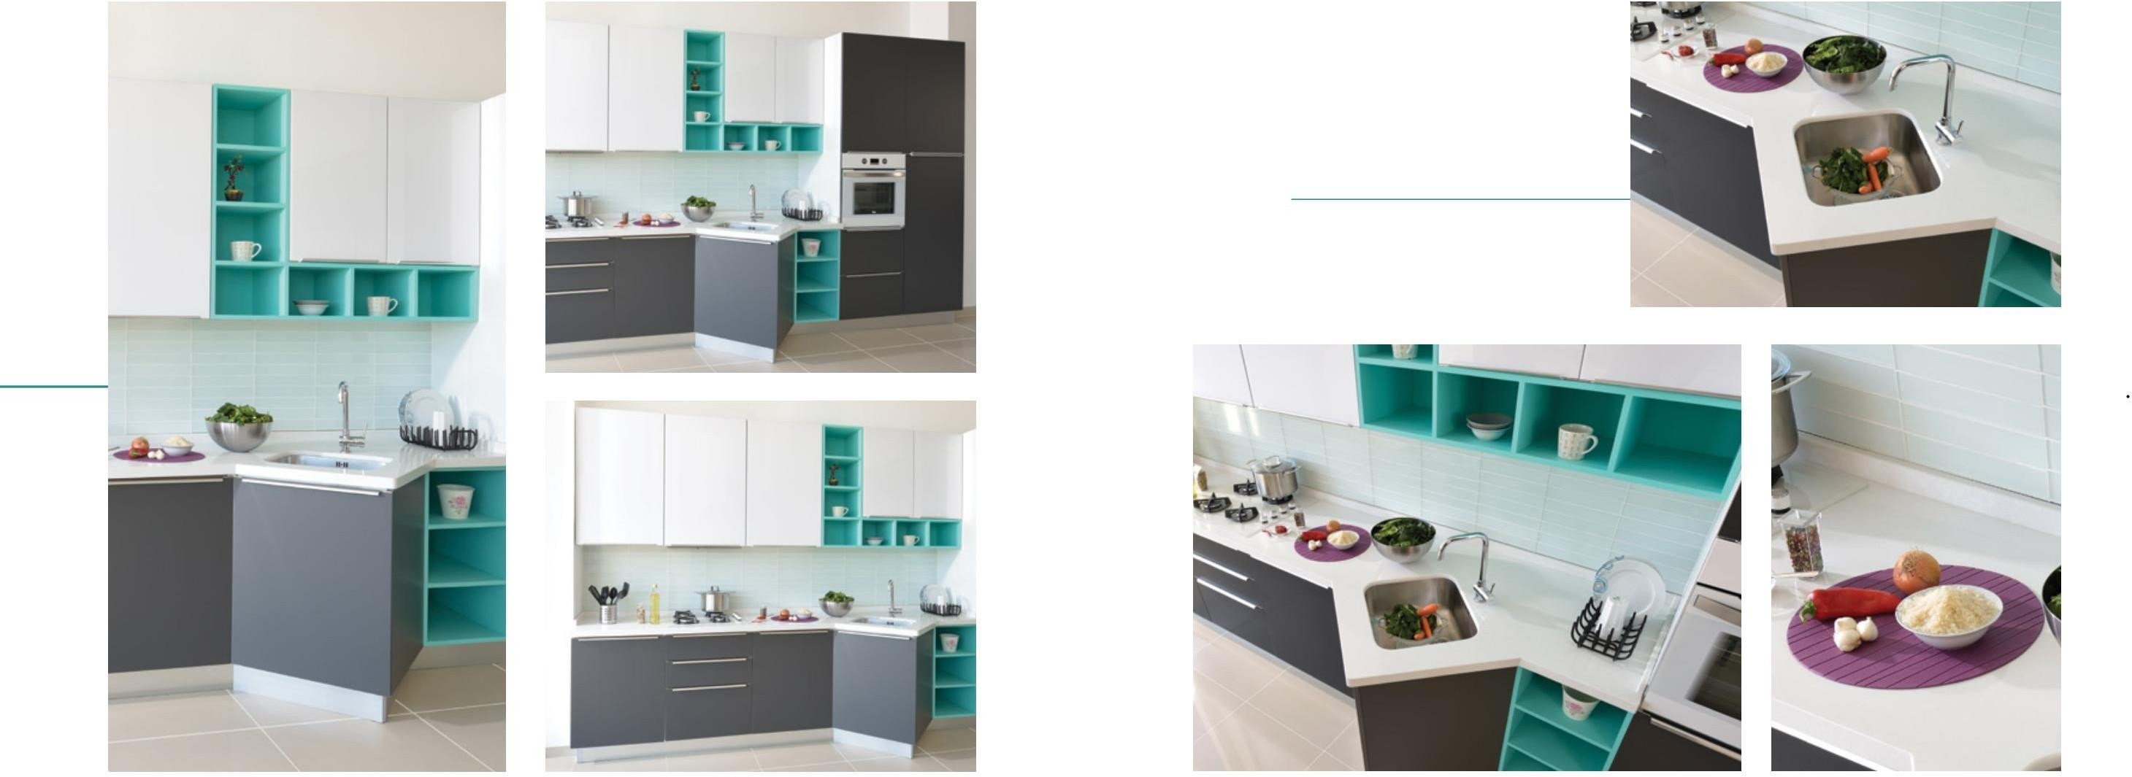Offering you functional solutions with its different sink design, Mimoza also adapts to your kitchen with its simple structure.

It provides you functional solutions with a different sink design. It easily fits into your kitchen with its simple structure.

###### SPMTLAK-3042

Cover | Door : *TopX-Acryl Glass-Supermat-Lake*

Model : *Z0GM*

Color | Color : *L01-Z10*

Body | Cabinet : *0301 MKYL-G07*

Handle | Handle : *Integrated | Integrated*

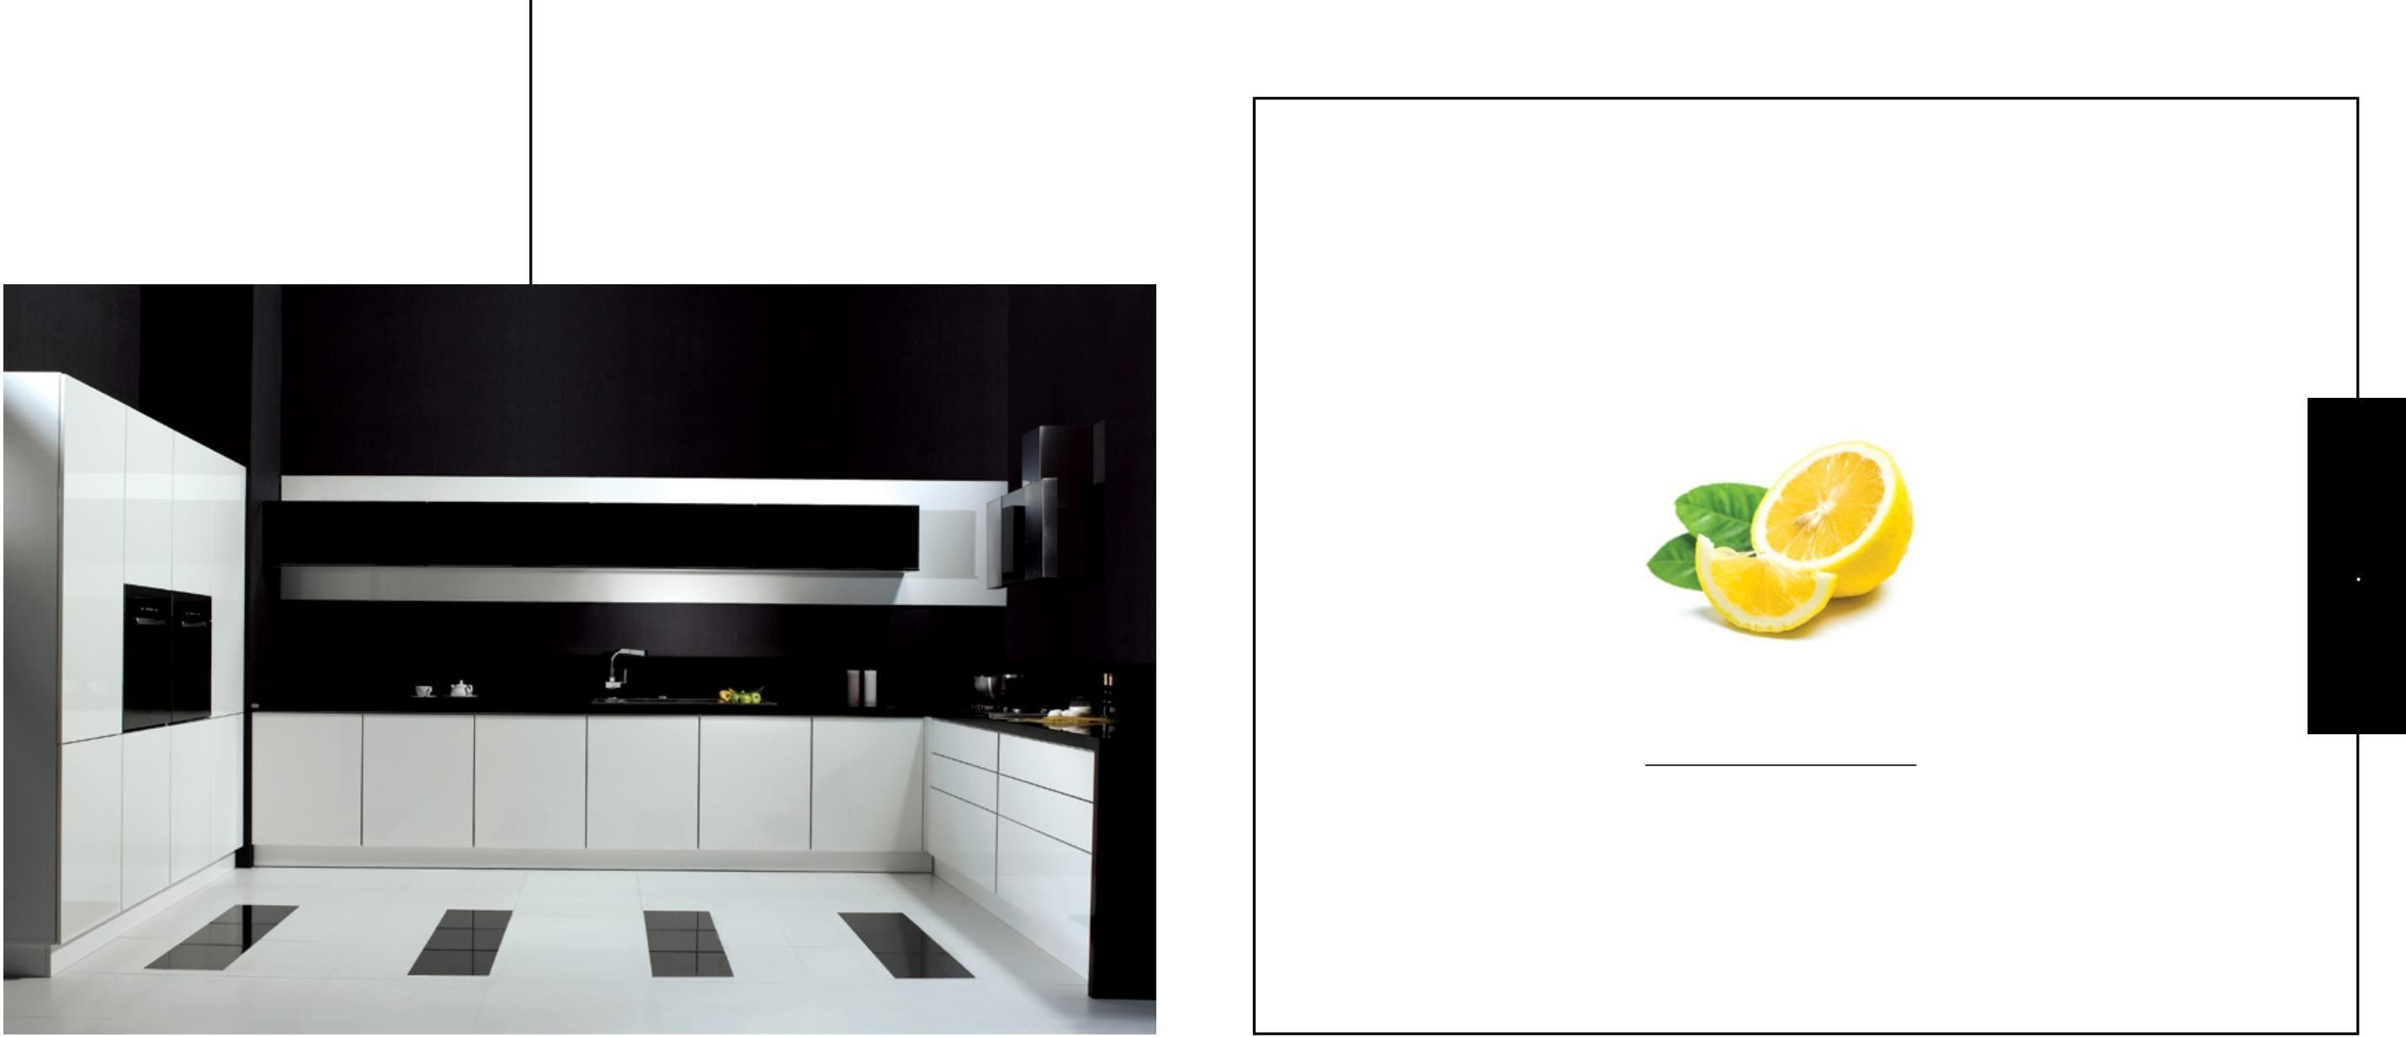

#### ELENAY

#### MODERN STYLE

Noble Touches of Black and White!

# ELENAY

You won't be able to resist Elenay's black and white elegance! You will not be able to resist Elenay's black and white elegance!

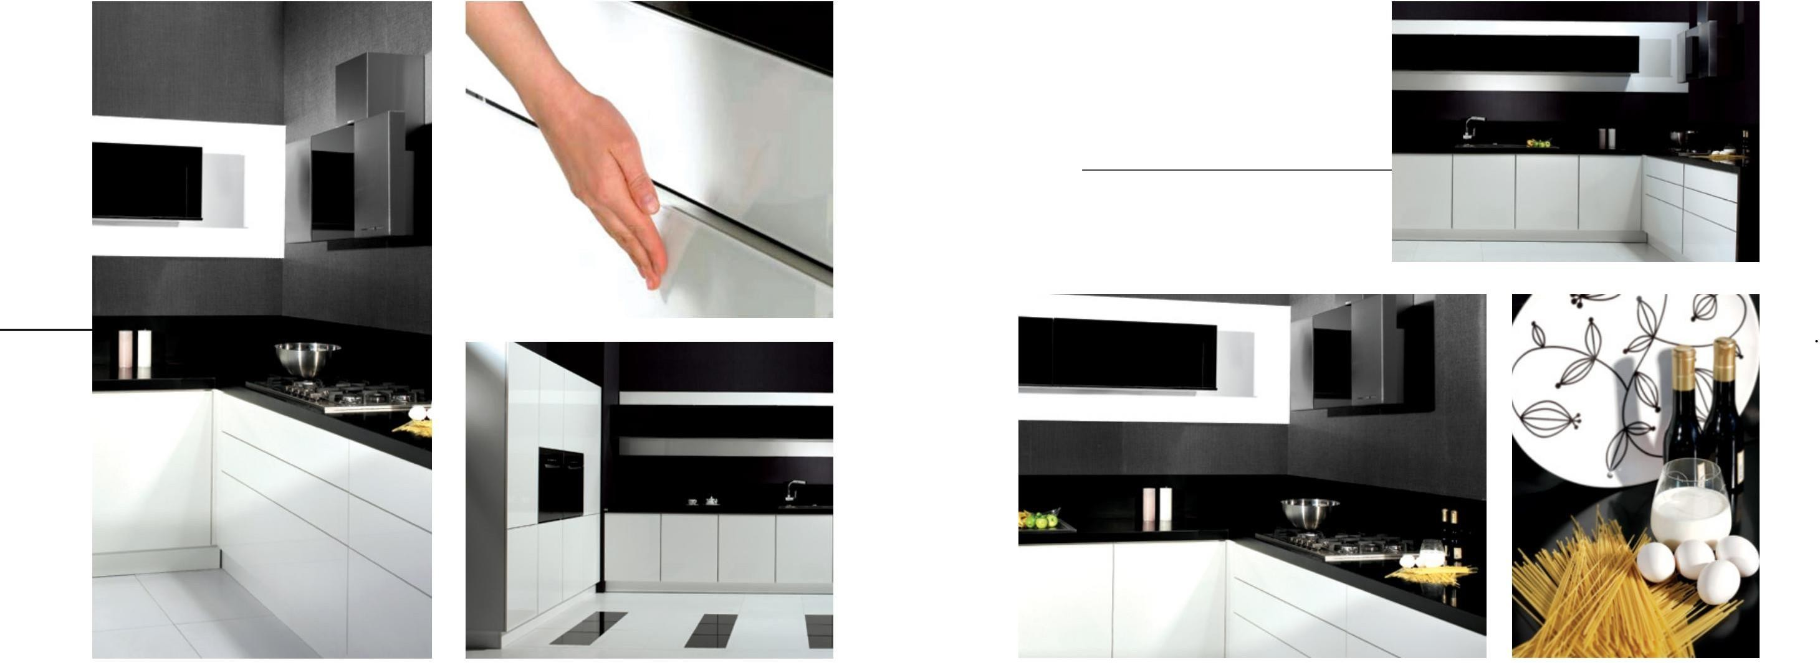While black and white combined with sharp lines reflect the nobility to your kitchen, cooking will be even more enjoyable.

While black and white, which are combined with salient lines, reflect nobility, it will be even more joyful to cook in your kitchen.

*LKSC-4222*

Cover | Door : *Glossy Lacquer | High Gloss Lacquered*

Model : *B001*

Color | Color : *G01*

Body | Cabinet : *0301 - MKYL*

Handle | Handle : *Bass Open | Press and Open*

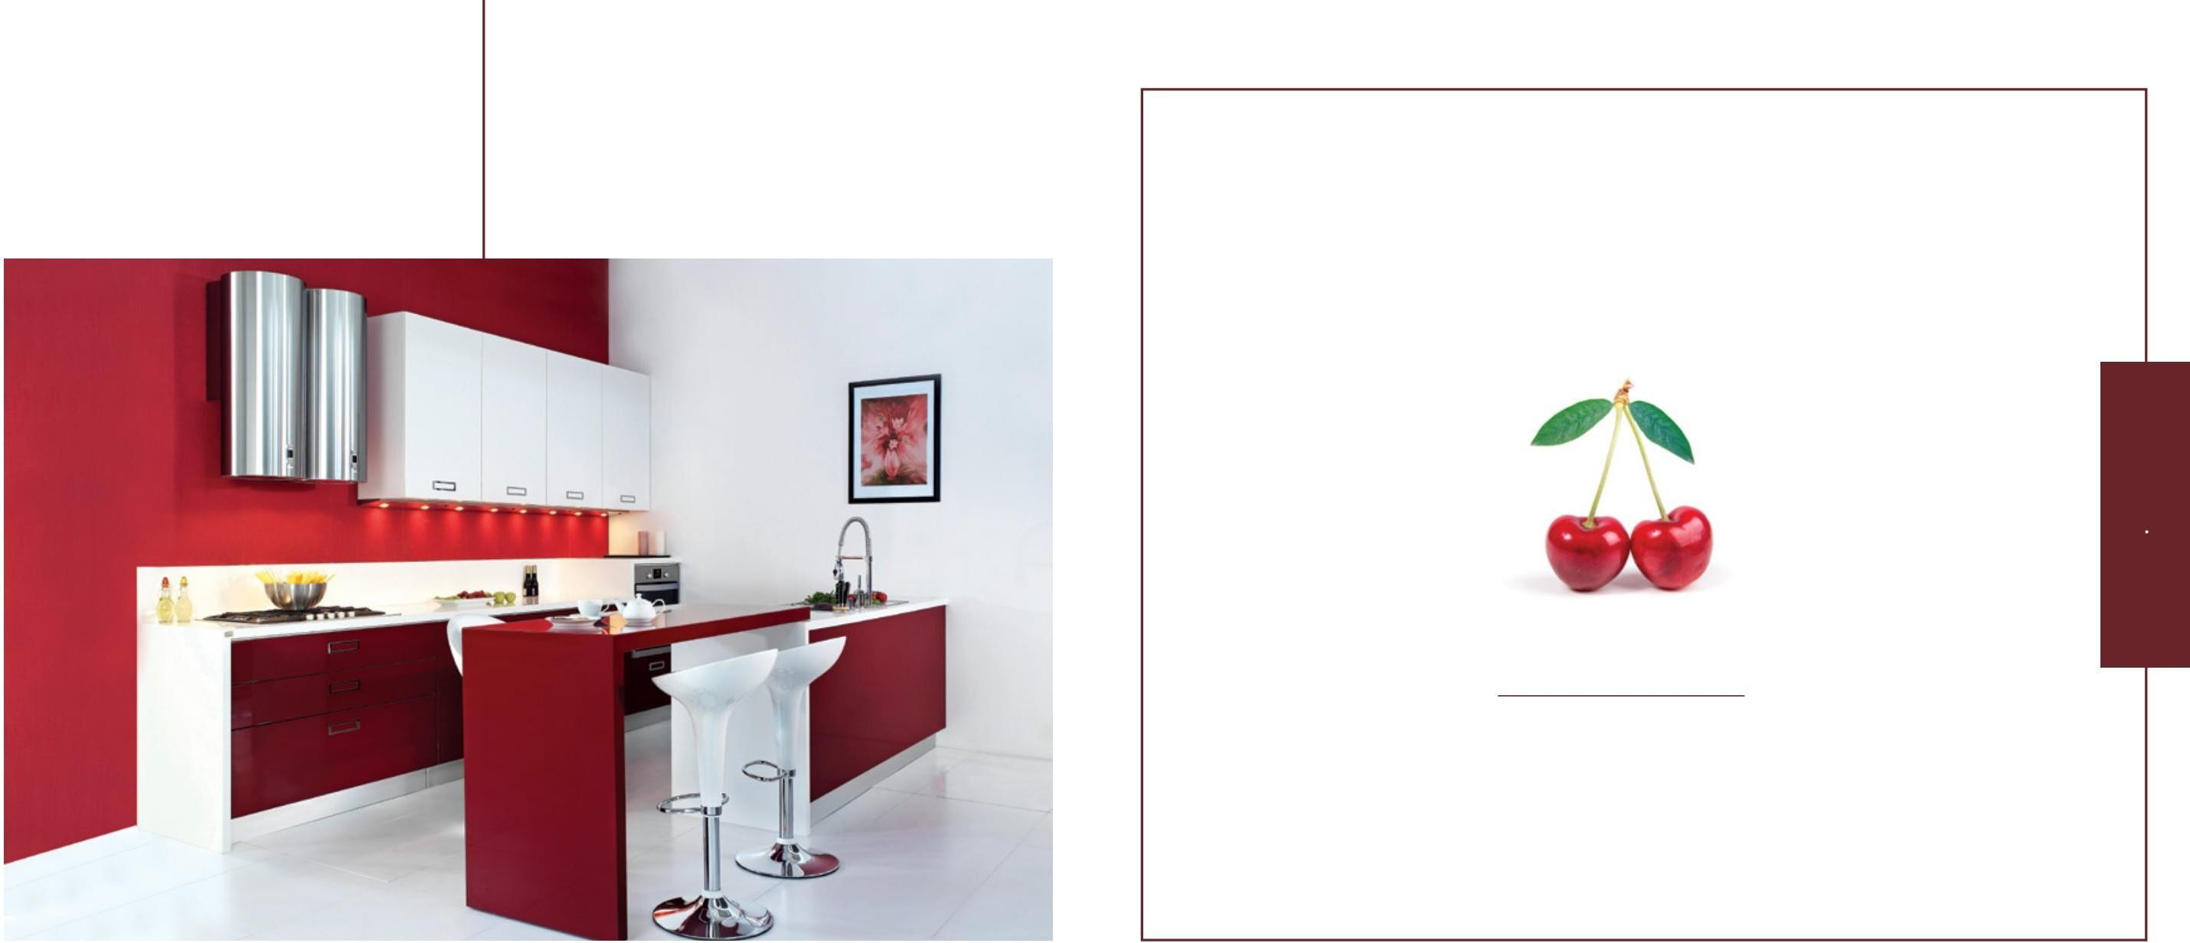

#### ALARA

#### MODERN STYLE

Delicacy is Hidden in Every Detail!

# ALARA

Feel the striking effect of red with Alara's comfortable design!

Feel the impressive effect of red with the ergonomic design of Alara!

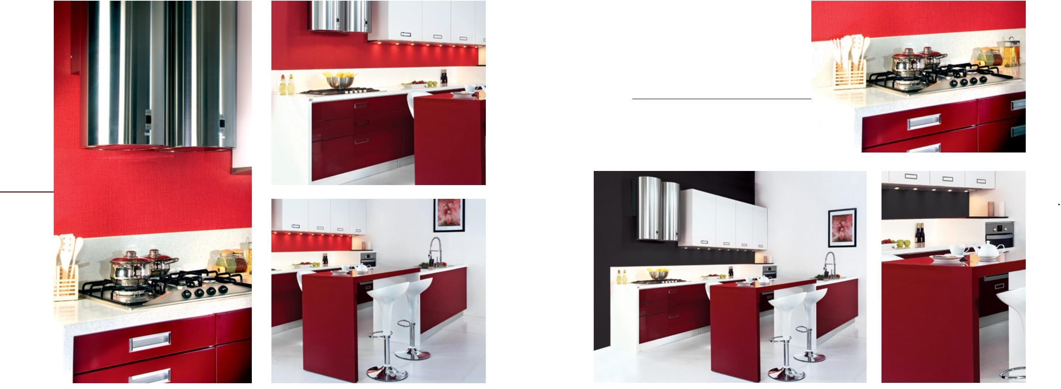Alara, which contains every detail about the kitchen, dazzles the eyes with its character and stance.

Containing every detail about the kitchen, Alara dazzles the eyes with its character and stance.

###### LKPB-4244

Cover | Door : *Glossy Lacquer | High Gloss Lacquered*

Model : *B0G2*

Color | Color : *G01- G03*

Body | Cabinet : *0301-MKYL*

Handle | Handle : *Integrated | Integrated*

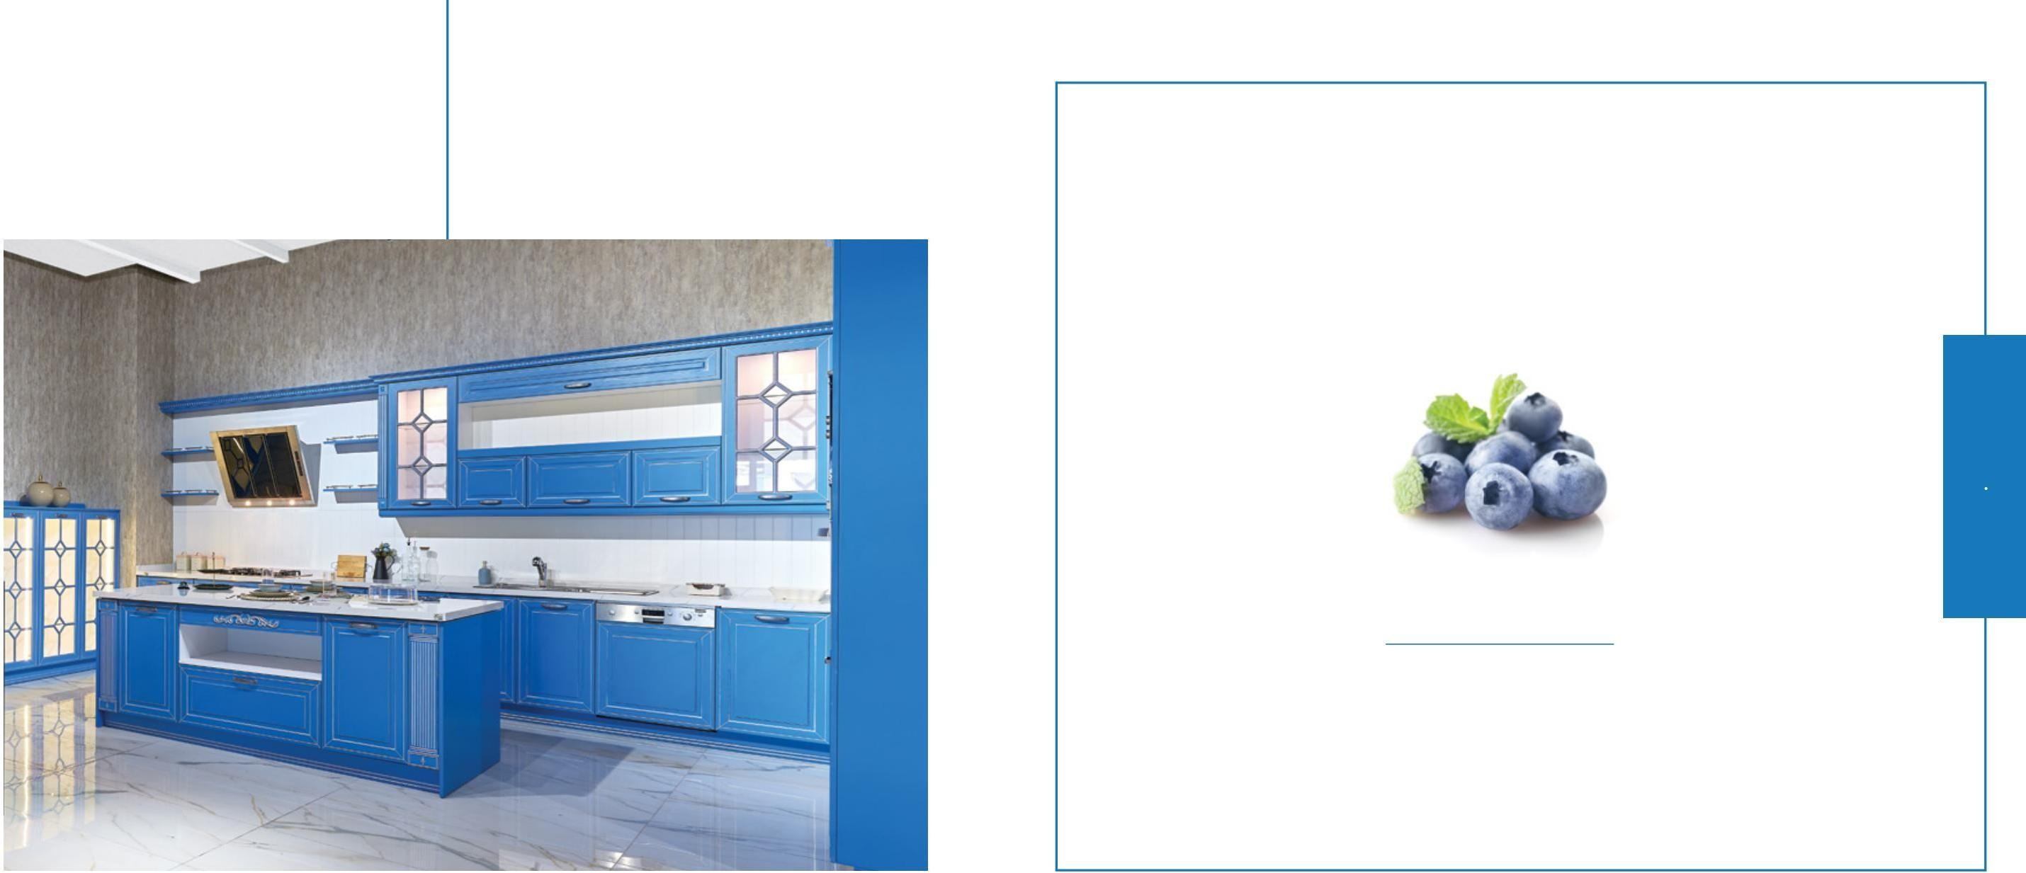

#### MARINE

#### CLASSIC STYLE

Reflect Your Classic Passion Into Your Kitchen!

# MARINE

You will not want to leave this peaceful kitchen with its color reminiscent of the sea!

Dazzling with its classic style and glass shelves, Marine is an ideal choice for those who want to add color to their kitchen.

You will not want to leave this peaceful kitchen which resembles the sea with its color.

Dazzling with its classic style and glass shelves, Marine is the ideal kitchen for those who want to give a magic

touch to their kitchen.

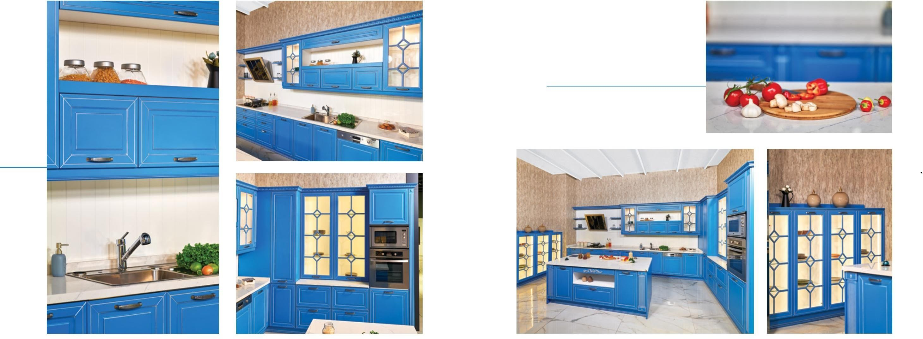Marine brings the inspirations of the classical style to your kitchen with the terek detail, which is the favorite of the old kitchens.

Marine brings touch of the classic style to your kitchen with the vintage shelves.

*LACQ-G10*

Cover | Door: *Lacquer*

Model : *BAS1*

Color | Color : *G10*

Body | Cabinet : *0301-MKYL*

Handle | Handle: *A84*

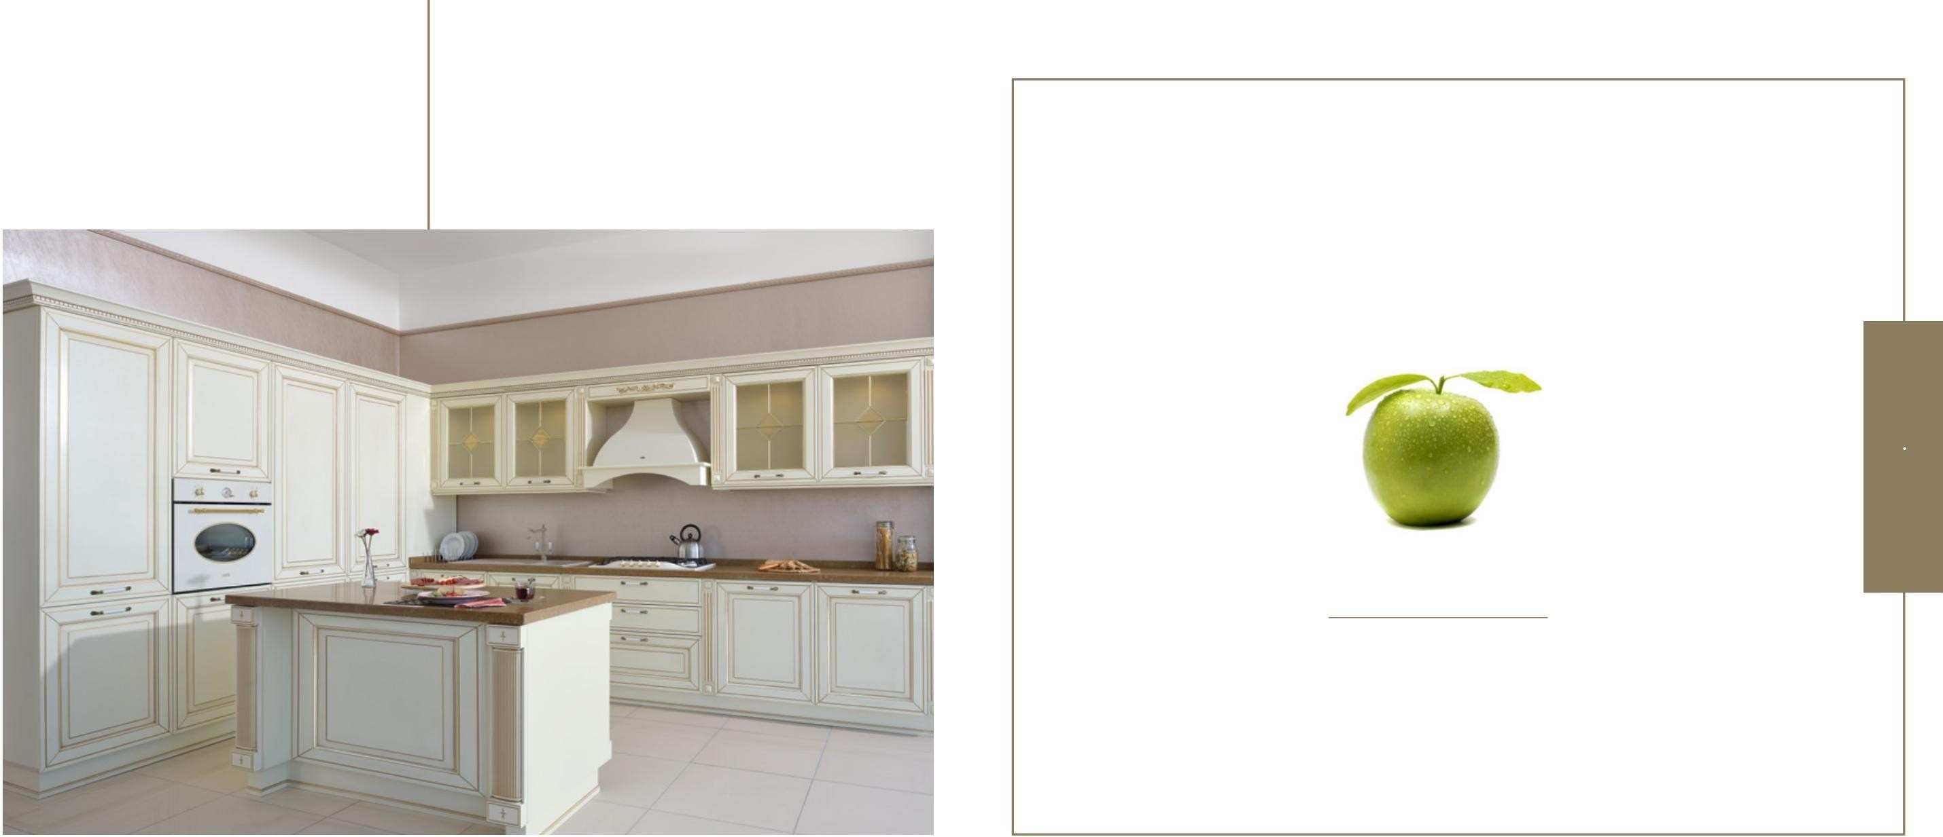

##### BEIGE GOLD

##### CLASSIC STYLE

The Choice of Vintage Enthusiasts!

## BEIGE GOLD

The incredible beauty of lacquer combined with elegance and aesthetics!

You will feel special thanks to its impressive handles and covers prepared for classic lovers.

The unbelievable beauty of lacquer combined with esthetics and grace.

You will feel special thanks to its impressive grips and cabinet doors designed for classic fans.

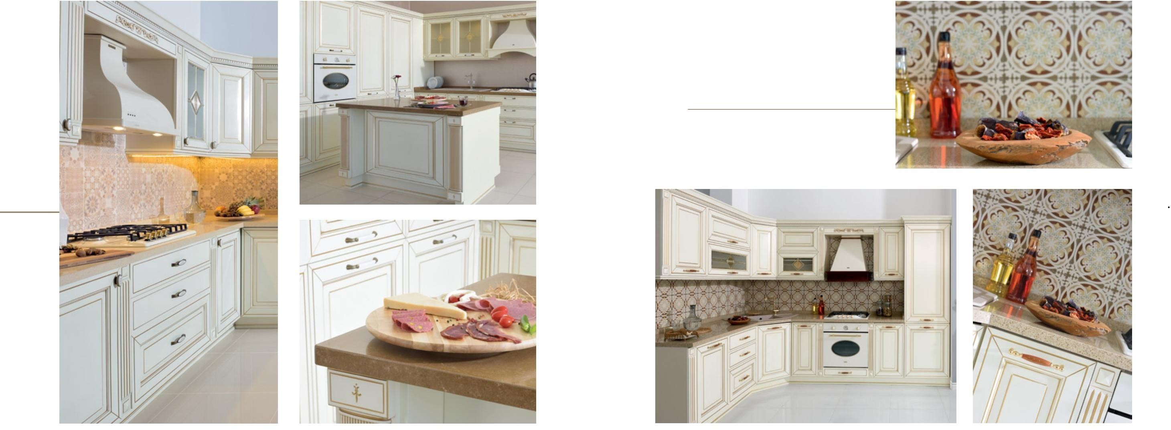With Beige Gold, which reflects the traces of vintage design, you can prepare your meal with great pleasure while returning to the times you missed.

With Beige, which makes you feel the breeze of vintage designs, you can prepare your meal with great pleasure while going back to the times you miss.

*CTR-1151*

Cover | Door : *Lake Gold | Lacquered Gold*

Model : *AV01*

Color | Color : *Q01*

Body | Cabinet : *0302-MKYL*

Handle | Handle: *A52*

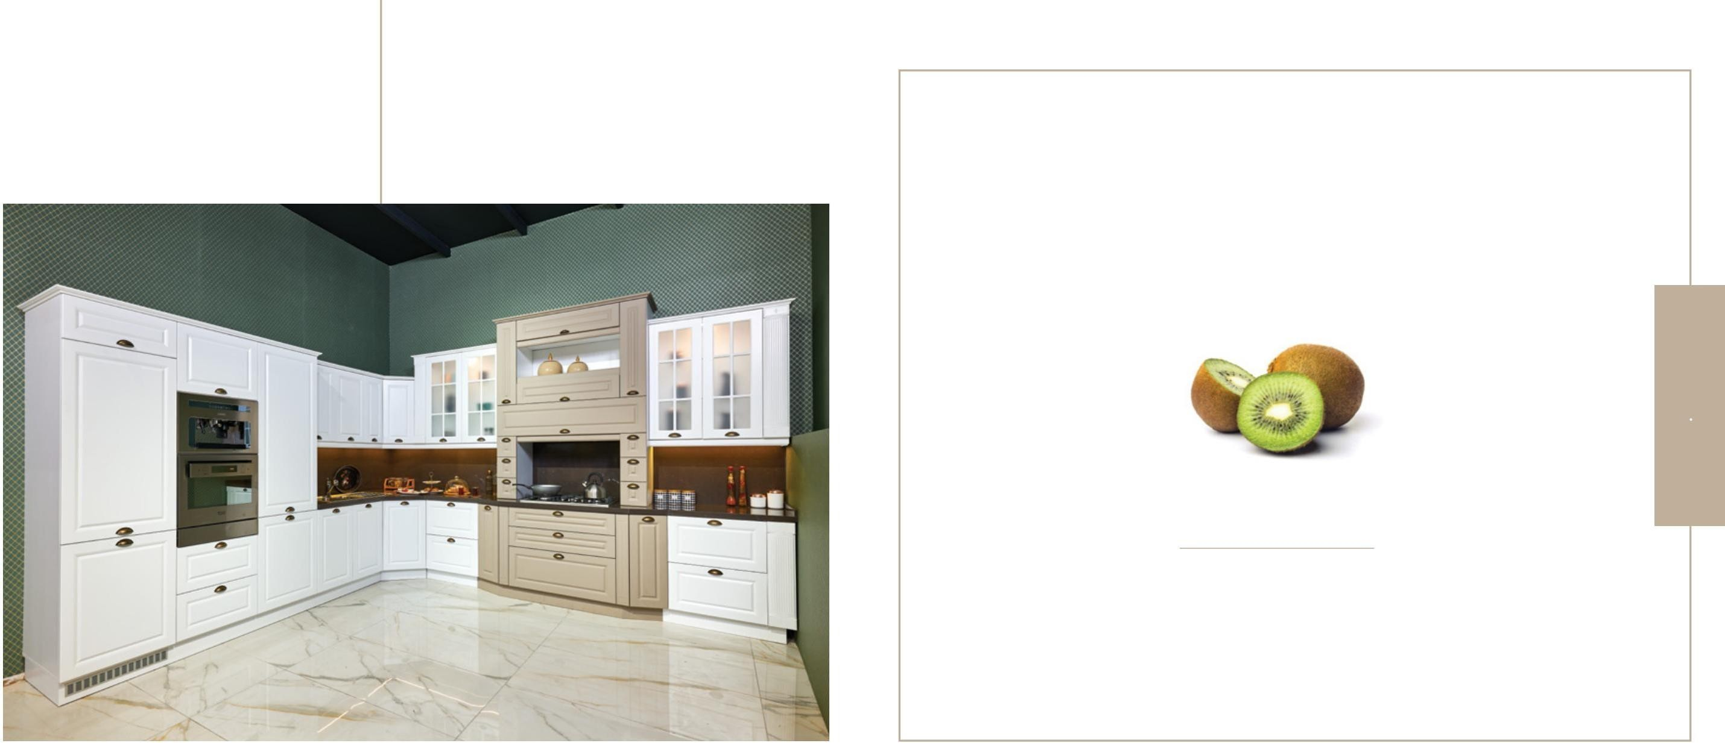

##### NOBLE

##### COUNTRY STYLE

The Noble Is Simplicity!

## NOBLE

We combined traditional details with modern lines!

Noble is the favorite of those who prefer simple and elegant touches in their kitchen.

We combined traditional details with modern lines.

Noble is the favorite of those who prefer simple and elegant touches in their kitchen.

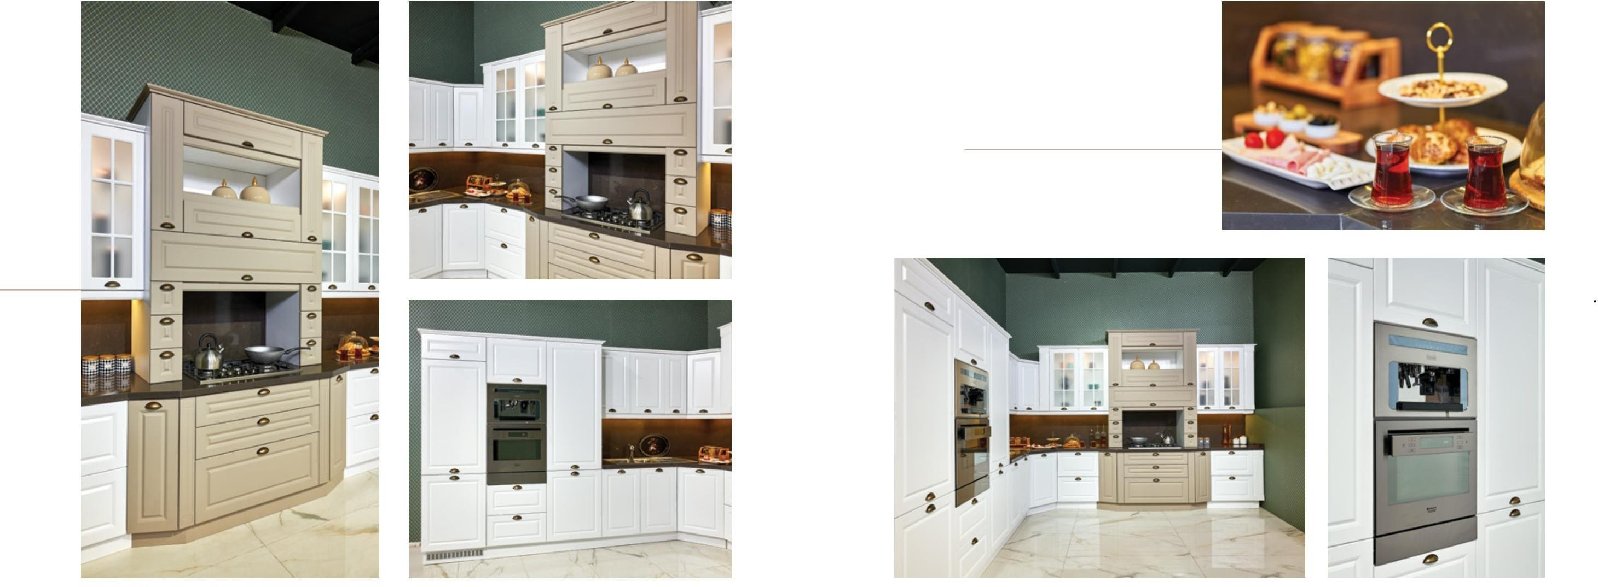Add a different atmosphere to your kitchen with details resembling a fireplace!

While reflecting the traditional touches to your kitchen, Noble offers its difference and comfort. you will feel.

Provide a pleasant atmosphere to your kitchen with details reminiscent of a fireplace!

You will feel the prominence and comfort of Noble, which reflects the classical touches to your kitchen.

*BODRUM-A04*

Cover | Door : *Thermoplastic Film 3D*

Model : *M030*

Color | Color : *A04-A73* Body | Cabinet : *0309-MKYL* Handle | Handle: *A07-3*

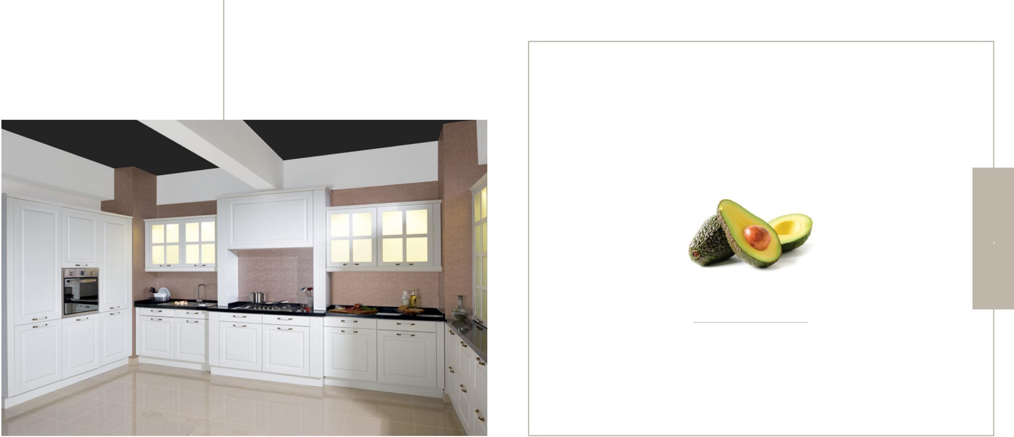

##### SWEDEN

##### COUNTRY STYLE

Simplicity Integrates with Stylish Touches!

## SWEDEN

A special concept for you that combines

today's and tomorrow's kitchen style with the limitlessness of design!

A concept uniquely designed for you blending contemporary and future kitchen conceptions with infinite design options!

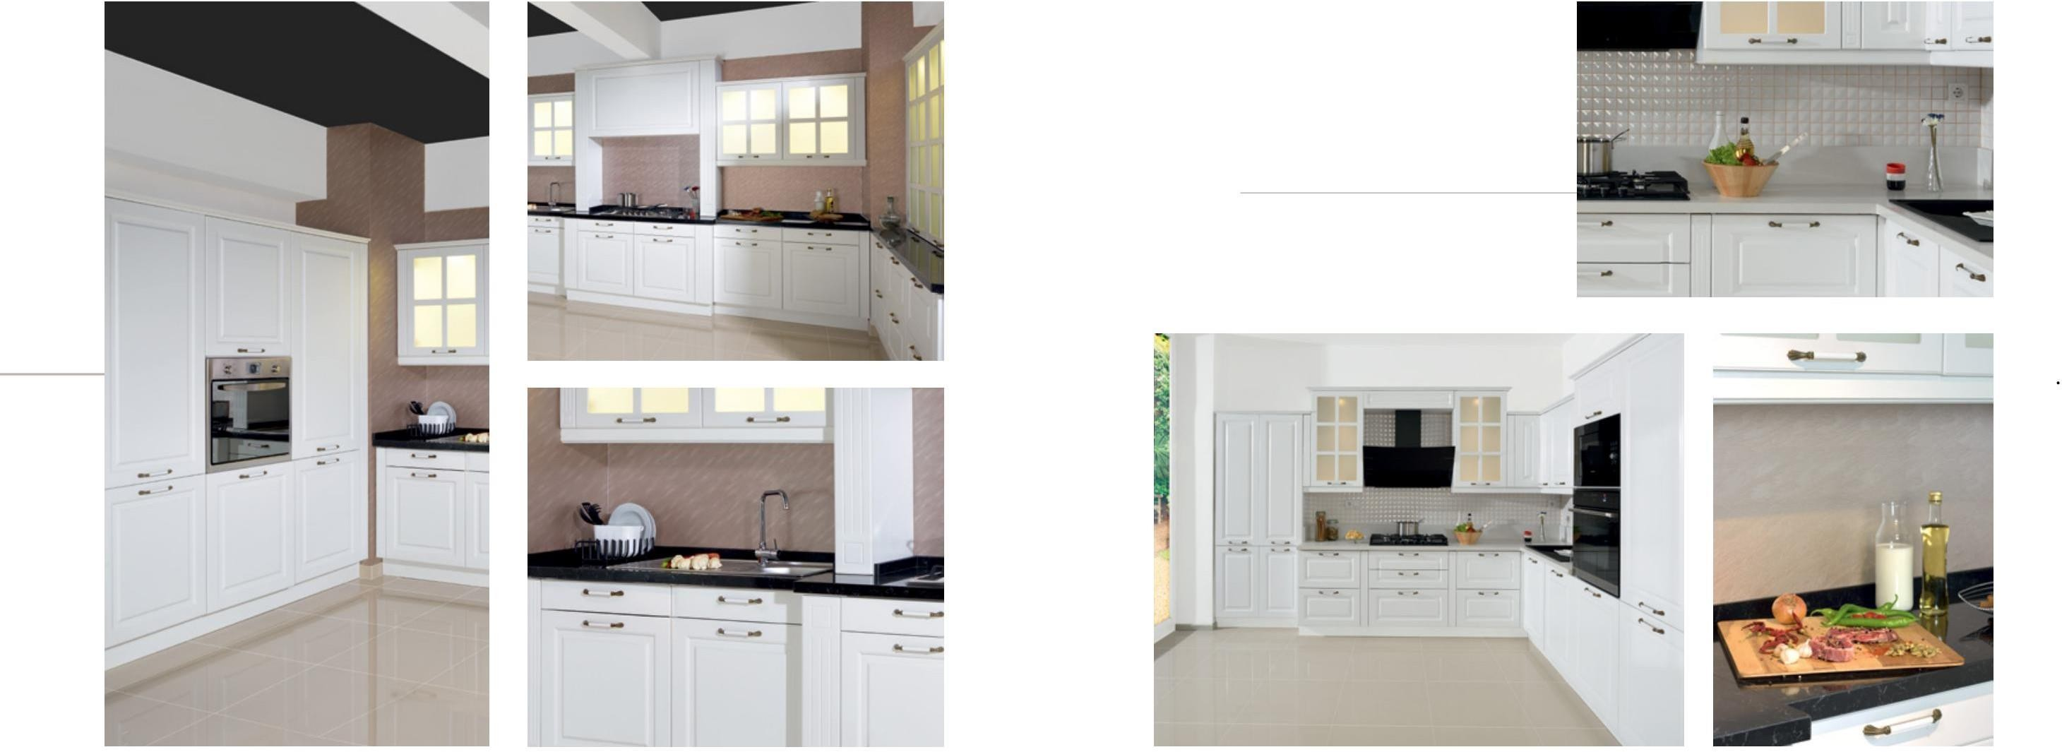Sweden has been designed so that you can have an always new, always modern kitchen with its design that accompanies the purity of white with its elegant lines.

Sweden, which accompanies the purity of white with elegant lines, was designed so that you can always have a new and modern kitchen.

*SWDCTR-1162*

Cover | Door : *Thermoplastic Film 3D*

Model : *M011*

Color | Color : *A78*

Body | Cabinet : *0301-MKYL*

Handle | Handle: *A*